Module 5.1 Database Dev Screenshots

April 5, 2025

Team Alpha:

* Andres Melendez
* Jeffrey Reid
* Edgar Arroyo
* Jordany Gonzalez
* Matthew Trinh

Contact Messages Table:

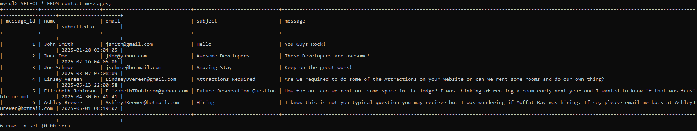

Reservations Table:

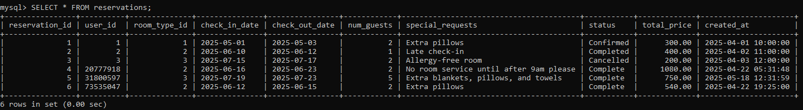

Room types:

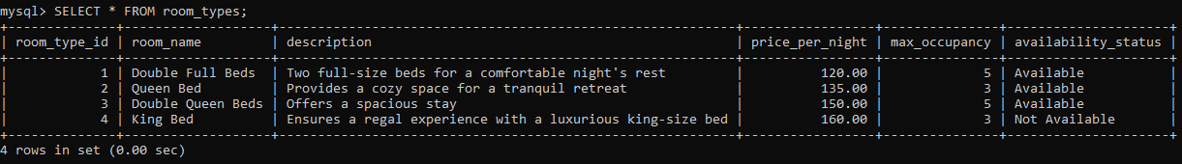

Rooms:

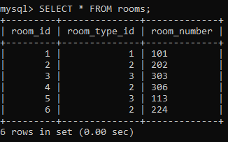

Users:

